|  |  |  |
| --- | --- | --- |
|  | | |
|  | **CMPS 350 Project Phase 1 – WebApp UI Design and Implementation**  **E Commerce Platform**  **(15% of the course grade)**  **The project code is accessible on the following (github) link: https://github.com/moumenkhha/Project.git** | |
| **Group Id:** | |  |
| **Group Members:** | | Moumen Abd Alkadr Alkhateb Alhasani (201910156)  M.Reyad Ahmad Tuama Halabi (201902988)  **Emails:** ma1910156@student.qu.edu.qa; mt1902988@student.qu.edu.qa |

**Grading Rubric - In the Functionality column please specify either: *Working (completed x%)*, *Not Working (completed x%)* or *Not done*.**

|  |  |  |  |  |
| --- | --- | --- | --- | --- |
| **Criteria** | **Weight%** | **Functionality\*** | **Quality of the implementation** | **Your Grade** |
| 1) Design and implement the app Web UI and navigation using HTML, CSS and JavaScript. Including designing the App Web UI and navigation. | 30 | Working (completed 100%) |  |  |
| 2) Design and implement the Web API and the server-side data access repositories to read/write the app data JSON files. | 60 | Not done. Local Storage is used for Phase1 |  |  |
| **3) Application Design:** Entities, Repositories and Web API class diagrams. | 5 | Not done. |  |  |
| **4) Testing documentation** using screen shots illustrating the testing results.  - Discussion of the project contribution of each team member. Members should collaborate and contribute equally to the project. | 5 | Working (completed 100%) |  |  |
| **Total** | 100 |  |  |  |

***Important remark:*** *In case of copying and/or plagiarism or not being able to explain or answer questions about the implementation, you lose the whole grade.*

**\* Criteria for grading the functionality:**

- The functionality is working: you get 70% of the assigned grade.

- The functionality is not working: you lose 40% of assigned grade.

- The functionality is not implemented: you get 0.

- The remaining grade in all cases from above **is assigned to the quality of the implementation**,

- The grades are distributed on the various use cases, when the design/implementation is partial, you get only the grades of designed/implemented use cases.

Code quality criteria, include:

- Use of meaningful identifiers for variables and functions (e.g. using JavaScript naming conventions)

- Pages are responsive

- Clean code: simple and concise code, no redundancy

- Clean implementation without unnecessary files/code

- Use of comments where necessary

- Proper code formatting and indentation.

**You lose marks** for code duplication, poor/inefficient coding practices, poor naming of identifiers, unclean/untidy submission, and unnecessary complex/poor user interface design.

**Important Remark**:

**[Grades: 100-85]:** Will be given only to **fully functional application** with **all the quality criteria cited above met** and the project has excellent **design for the various functionalities**. **The report is professional**.

**[Grades: 85-80]:** Will be given only **to fully functional application** **with most of all the quality criteria cited above met** and the project has good design for the various functionalities. **The report is professional**.

**[Grades: 80-75]:** 80% of the application functionalities are functional. The project respects partially the quality criteria. **The report is professional** but misses some iformation.

The grades are not negotiable. We expect that only a small portion (around 15%) of the class will be able to meet the criteria for the grades **[100-85]. You should work hard to and demonstrate the merits of your application to earn those grades.**

# Description of your proposed platform: A website to purchase books.

# Application Design

# Entities class diagram

# Use case diagram

# Web API class diagram

# Implementation

# Implemented use-cases:

# 1 [Login],

# 2 [Search Available],

# 3 [Purchase an item],

# 4 [View the purchase history].

# Unimplemented use-cases and not functioning parts

# 5 [View available items on sale and sale history]

# 6 [Upload an item to be sold]

# Testing

# Use case 1

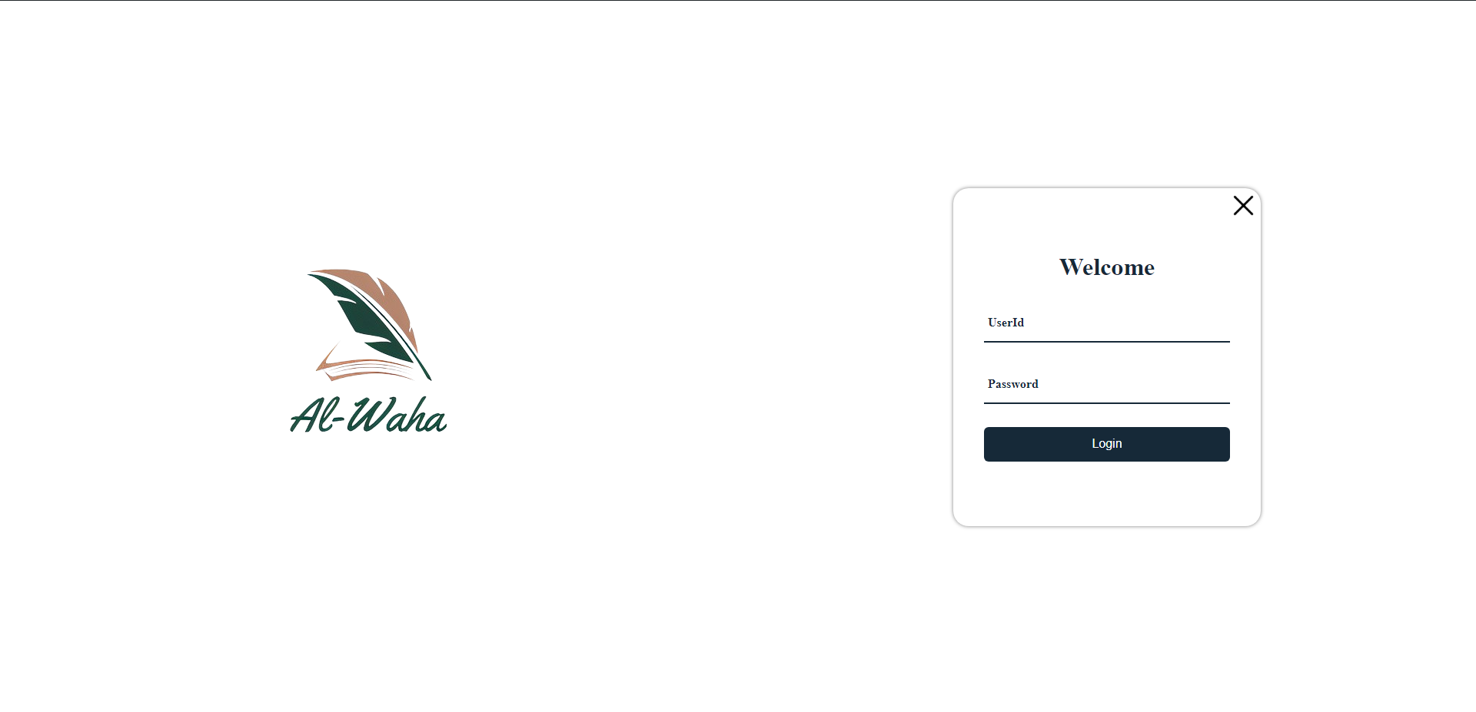

# Use case 2

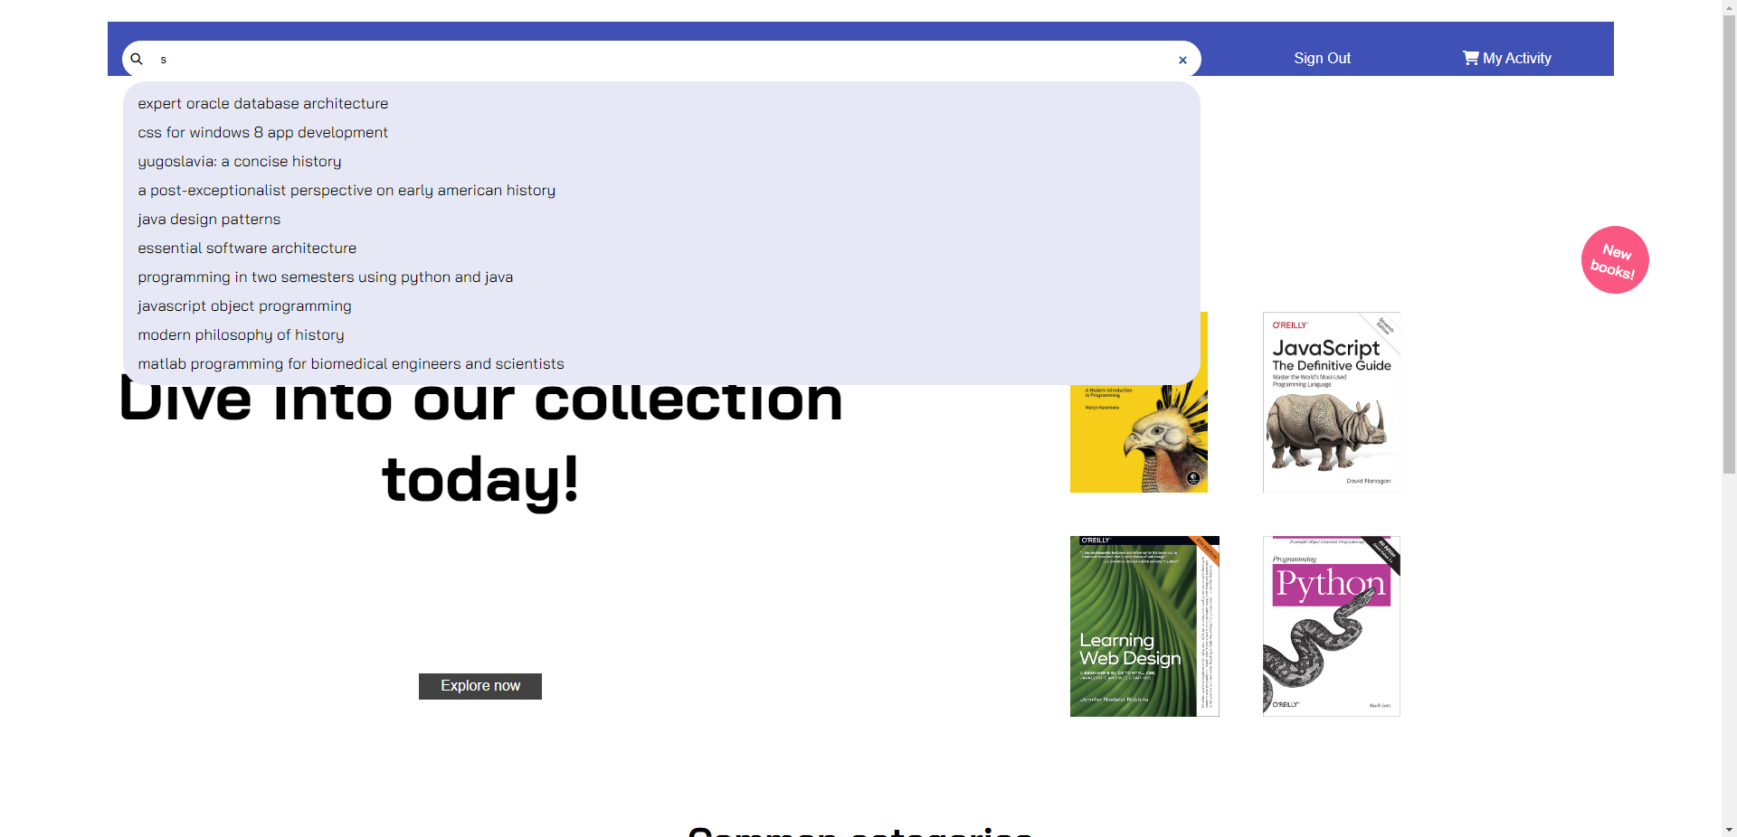

# Use case 3

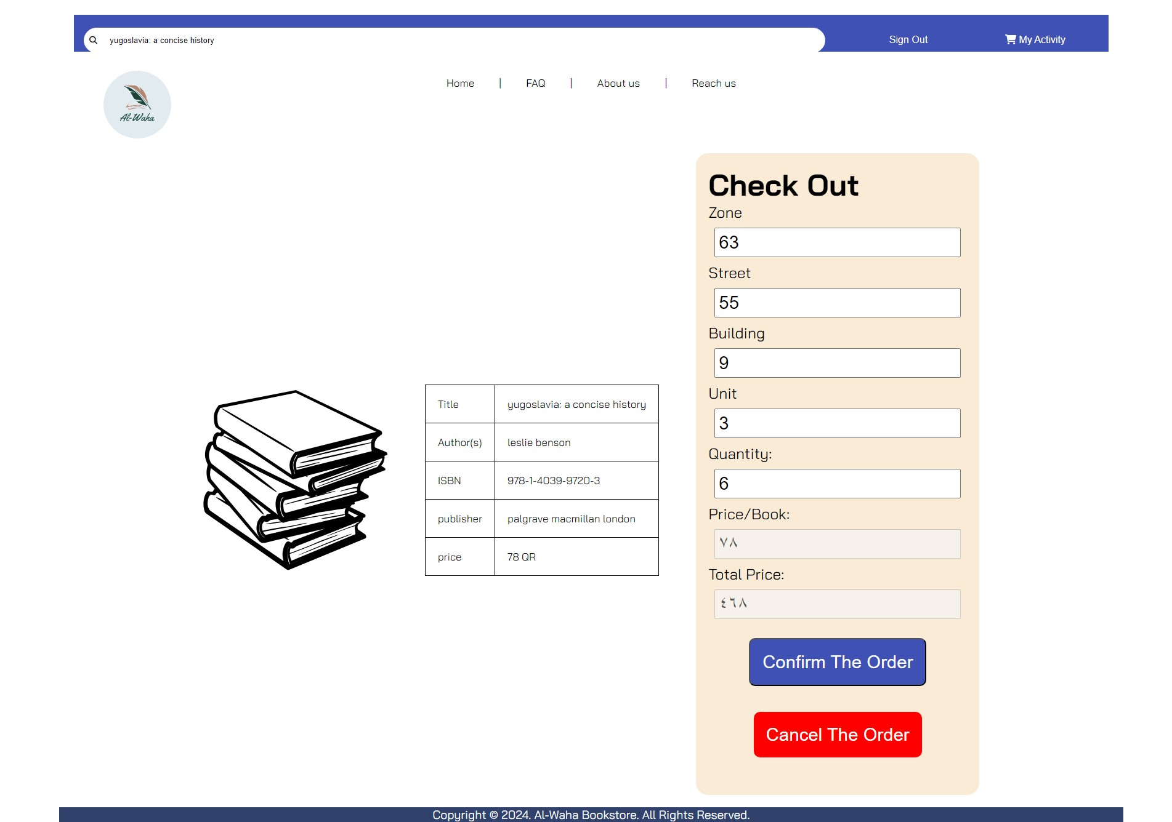

# Use case 4

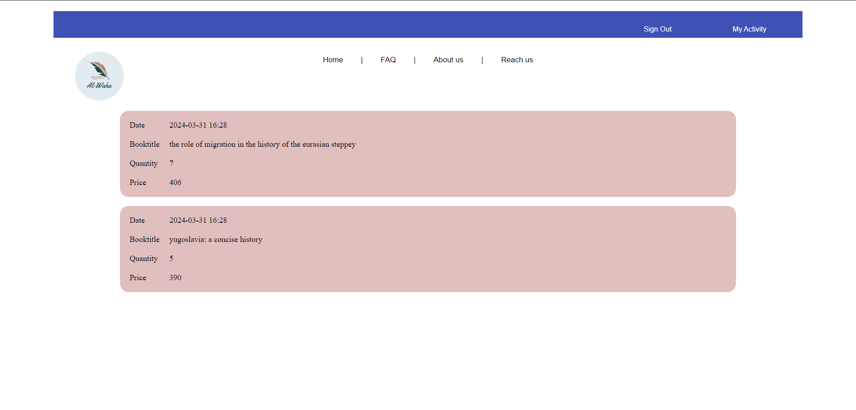

# Use case 5

# Use case 4

# Discussion of the project contribution of each team member